# Integration, test, and flight report. NGEN on ICI-4

January 25, 2015 to TBD

# Electronics Hardware

The NGFM was integrated with ICI-4 generally as-described on the V1.0.0 eagle schematic. Notable hardware differences were:

1. Feedback resistor for sensor preamp (e.g. R231) was changed to a Vishay ultra low temp coefficient 1k000 resistor. The parallel capacitor (e.g. C001) was increased correspondingly but the exact value was not recorded.
2. The digital flux feedback circuit was left open circuit (e.g., JP1 open)
3. The weak-bandpass filter was left in circuit and left at its original frequency despite the minor miss-match with the drive frequency (e.g., jumper pins 2 and 3 in JP6)
4. The incorrectly wired differential driver before each ADC was corrected using board rework.
5. VCC_PUMP was provided via the board by connecting pins 6 and 7 of JP7.
6. The USB interface (sheet 11) was not populated.

## Anti-aliasing band pass circuit:

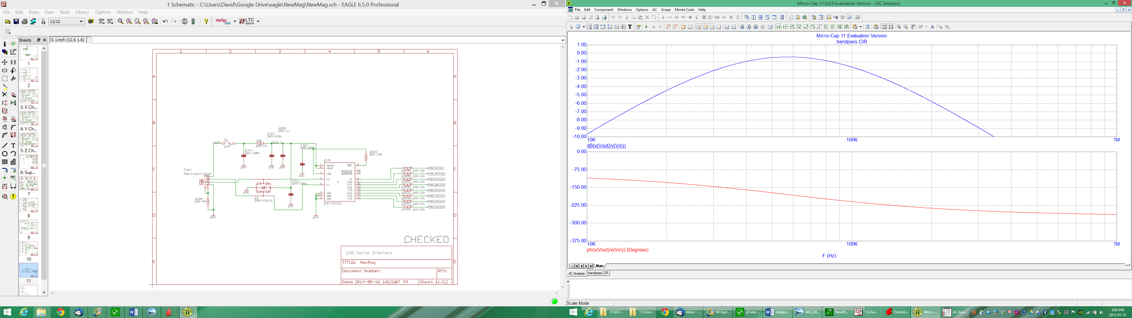

## Corrected ADC Driver:

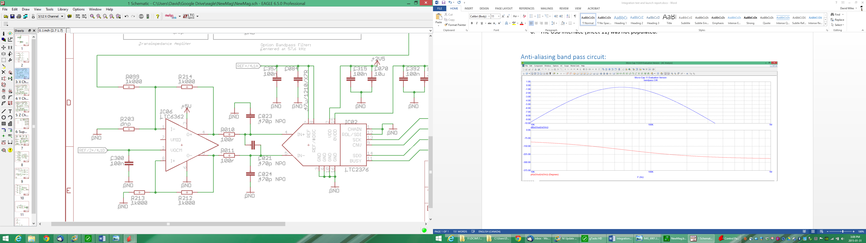

## Sensor Construction

The bobbin/mount for the flight sensor as designed in solidworks by David Barona and fabricated from Macor by the U. Alberta Physics shop. The ring-cores were supplied by John Bennest who also wound the coils and provided the termination board and the cabling. During fabrication one contact point for one bobbin was cut too deeply by the machine shop. The shop fabricated custom macor washers to allow the bobbin to sit in the correct position.

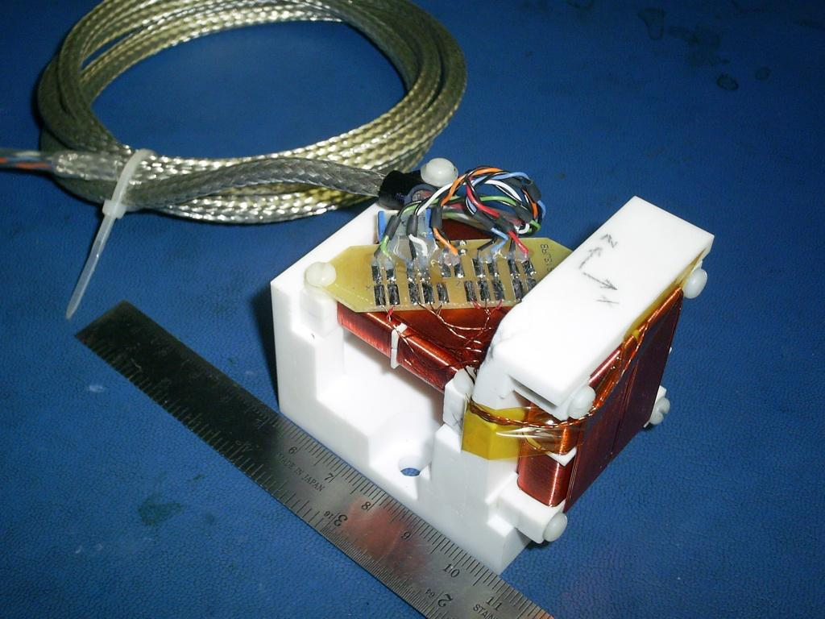

From John’s email:

Hi Dave,

ExPost # 0649 1470 0039 3879 is heading your way, hopefully to arrive Friday??

A few notes:

- the non-magnetic cap is 47 nF. Cable colour-coding is our usual standard: X, Y, Z are red, green & blue, drive is white, and temperature is orange.

- there are two exposed pads on the circuit board intended for your temperature sensor. With some care it should be possible to make solder connections without dismounting the card. Be quick enough with the pencil so as not to heat up the orange and black wire pair to the point where their solder joints melt. Note that all the cable lead wires are secured into place with RTV, which provides some safety. As always, I’m aware that I may be asking you to teach your grandmother how to suck eggs...

- the little cardboard tube now contains a number of M3 nylon screws just in case. A new blade in any boxcutter knife will cut them to length quite nicely. My habit with nylon screws is to tighten them one [and only one] full turn after they’ve hit finger-tight – the screw may make stiction complaints while you do this, don’t be alarmed – tapped holes in macor aren’t terribly smooth, but you want the screw to stretch slightly to provide a healthy tension force.

- I’m not sure if the polarization of this sensor matches what I did on the 3D-printed prototype, nor whether it is what you want, but this can easily be adjusted at the connector when you attach it to the free end of the cable. The pencil arrows on the Macor base indicate the present orientation.

- similarly, I don’t know whether the cable-clamp arrangement will work for you. Someday when there is some time, we should spend some time establishing standard sensor orientation, cable location, etc and documenting same.

- overall fit and finish of the macor parts is excellent; I wouldn’t change anything other than the obvious. The little macor spacing washers are works of art!

- If you ever dismount the sensor bobbins from the base, be very aware of the fact that the outer windings extend beyond the macor bobbin, and can easily be injured if the bobbin is slid sideways in the base. More grandmothers & eggs.

Enough babble. Say hi to Don Wallis for me.

Best regards,

.. John ..

# NRCan Calibration

The sensor and electronics were calibrated at the NRCan geomagnetics laboratory in August 2013. Note that the electronics were subsequently changed (feedback was active during these tests) so extreme care must be used in interpreting these test results.

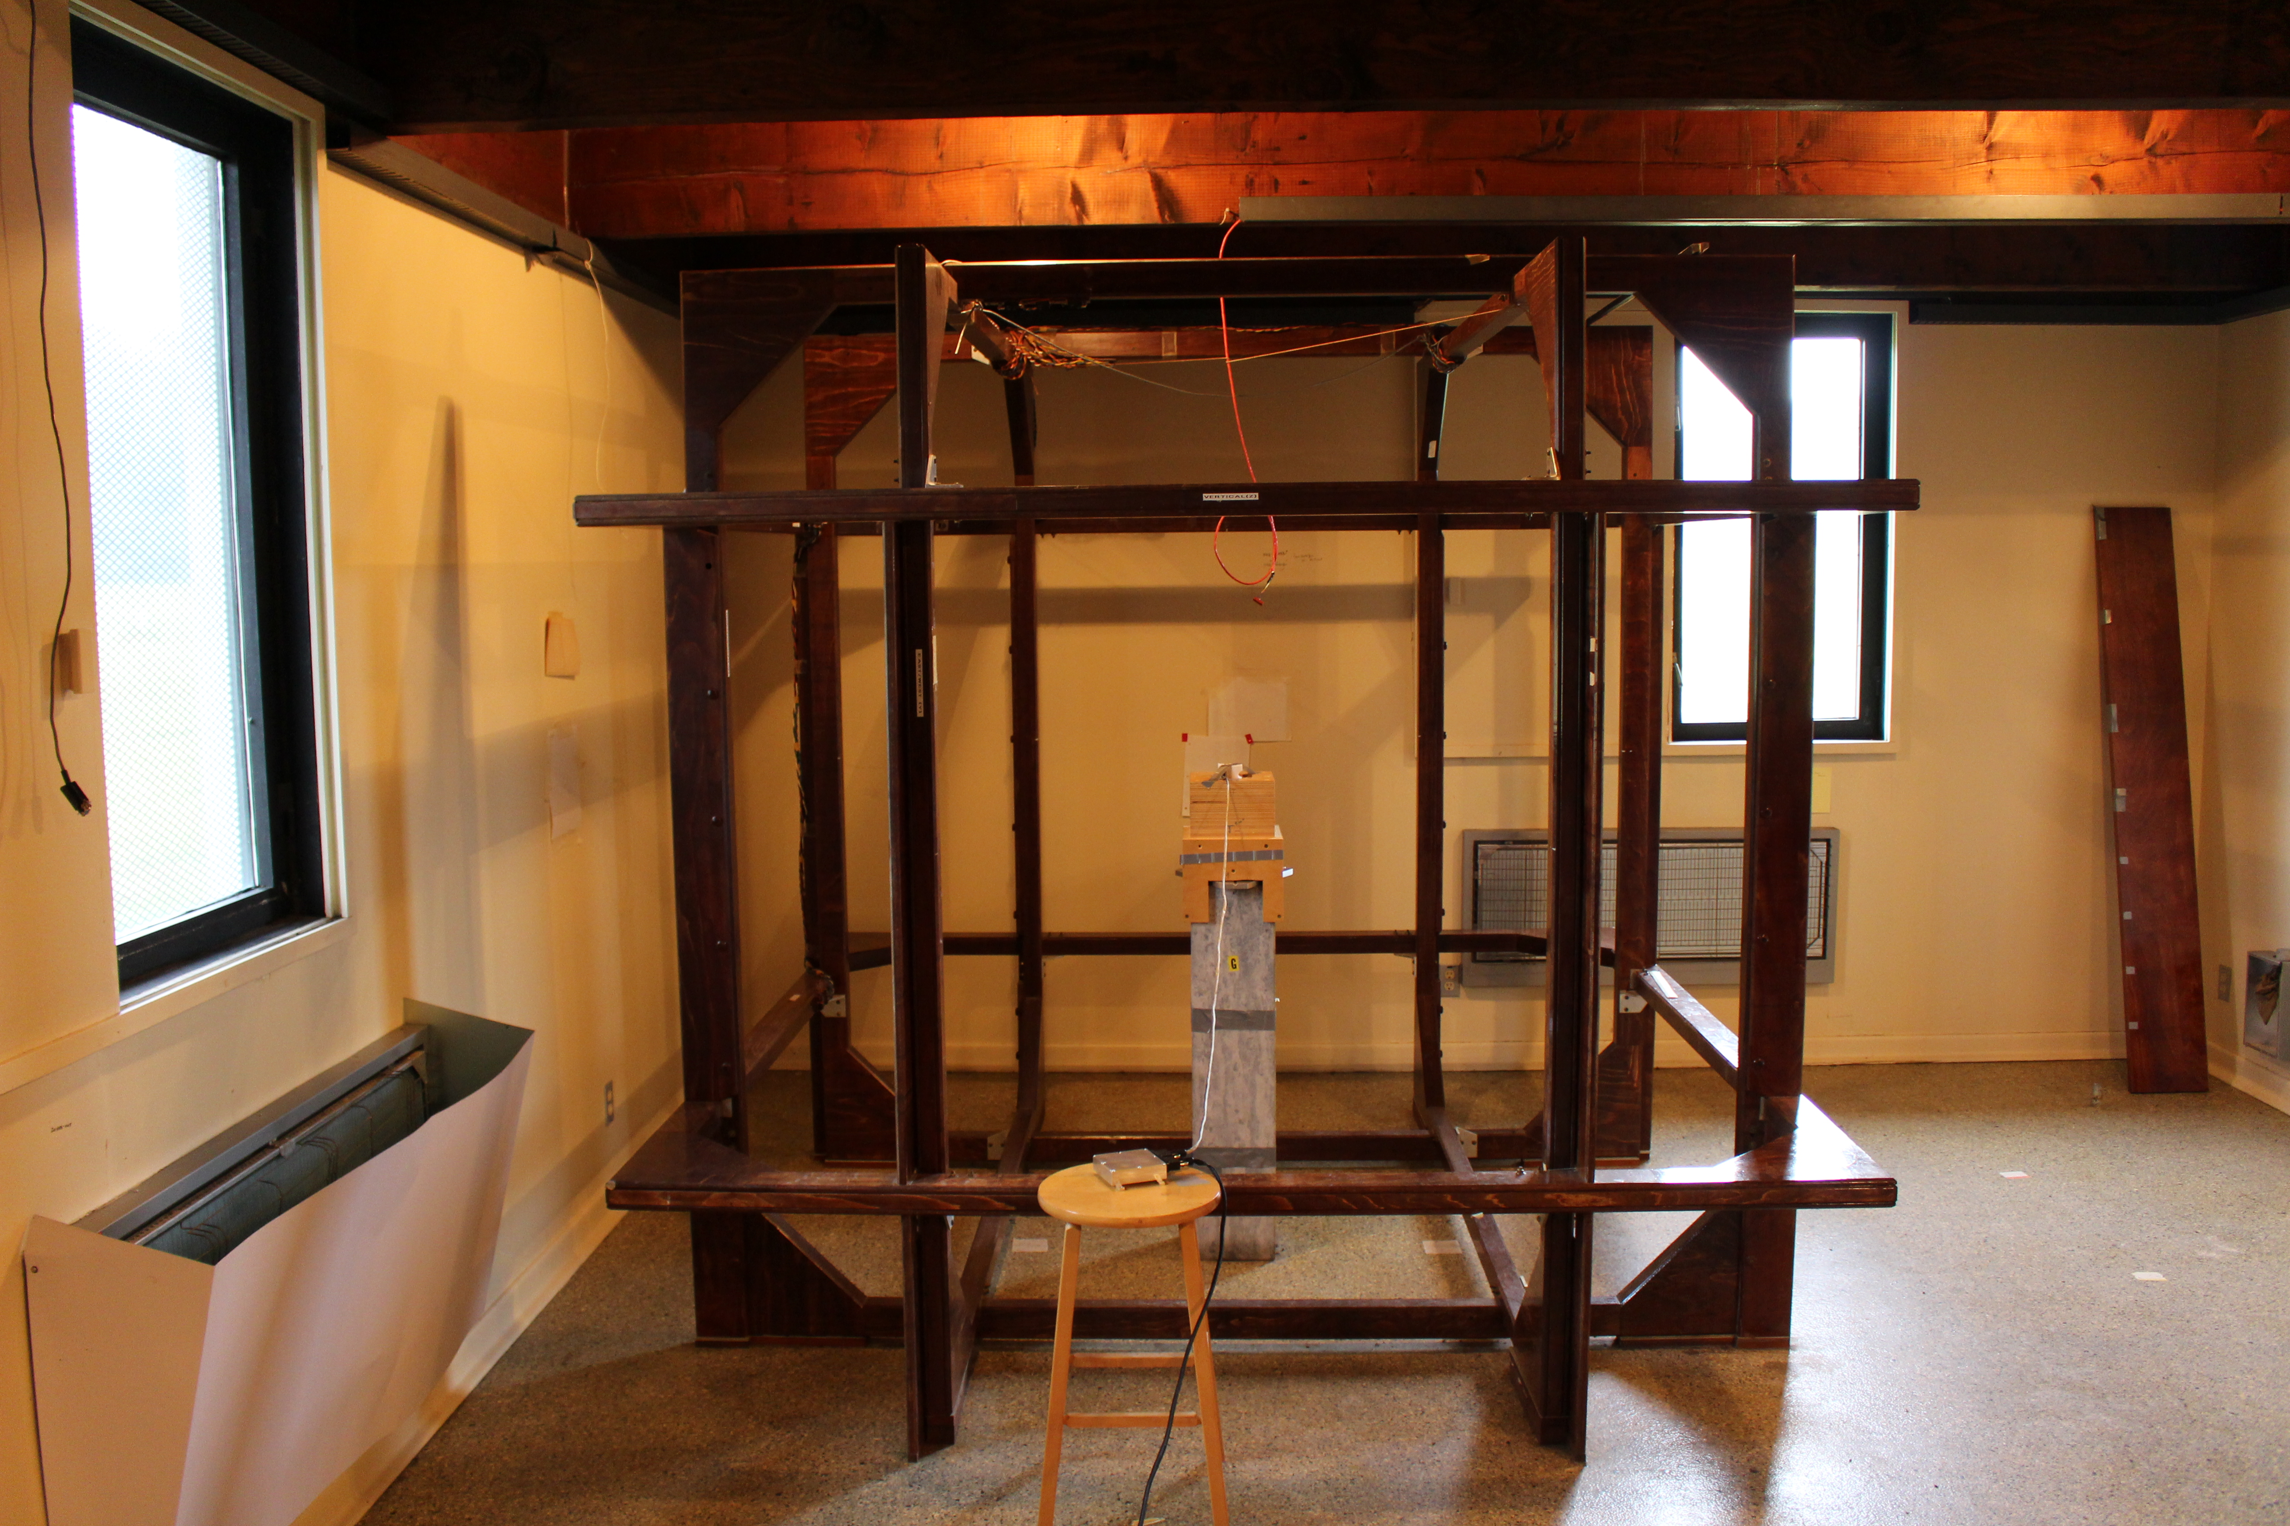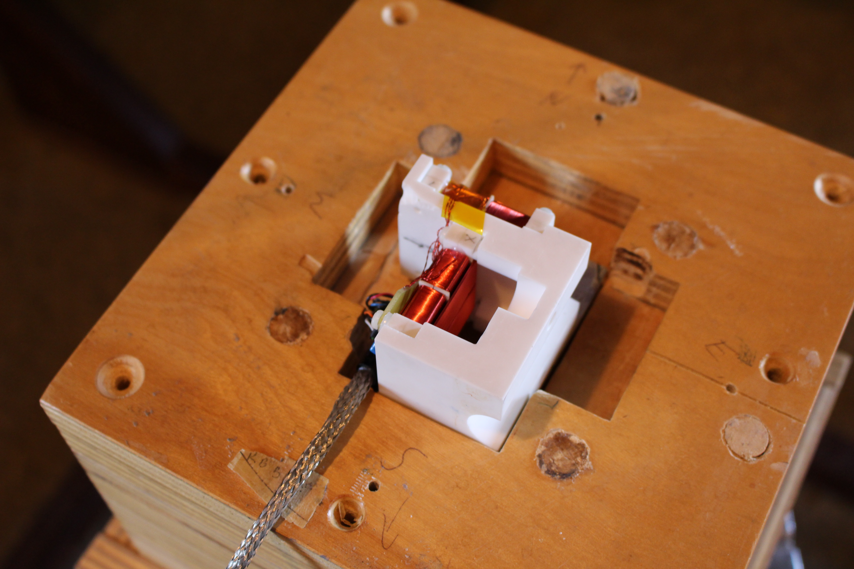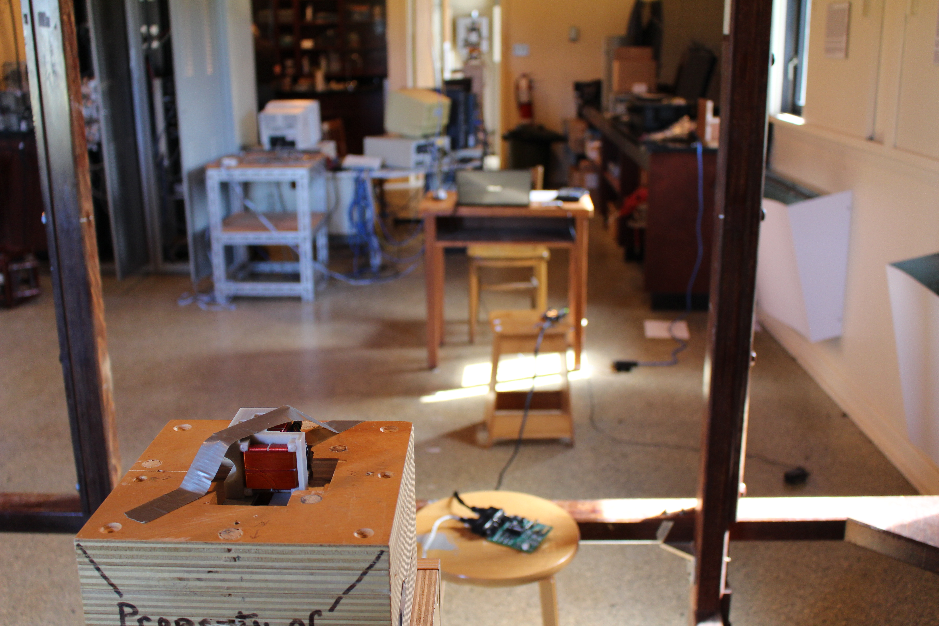

# Sensor integration

The flight sensor clamshell is closed at both holes via: brass bolt, brass lock washer, bronze spring washer, brass nut, brass nut all treated with lock-tight. The flight sensor is tacked in place with two brass bolts into the aluminum boom secured with lock-tight. The sensor cable has a pressure fit strain relief into the end of the aluminium boom.

All bolts were verified finger tight on 2015-02-02 and the large bolts showed some minor evidence of oxidation? (blue/green residue between bolts.) System seemed mechanically robust though.

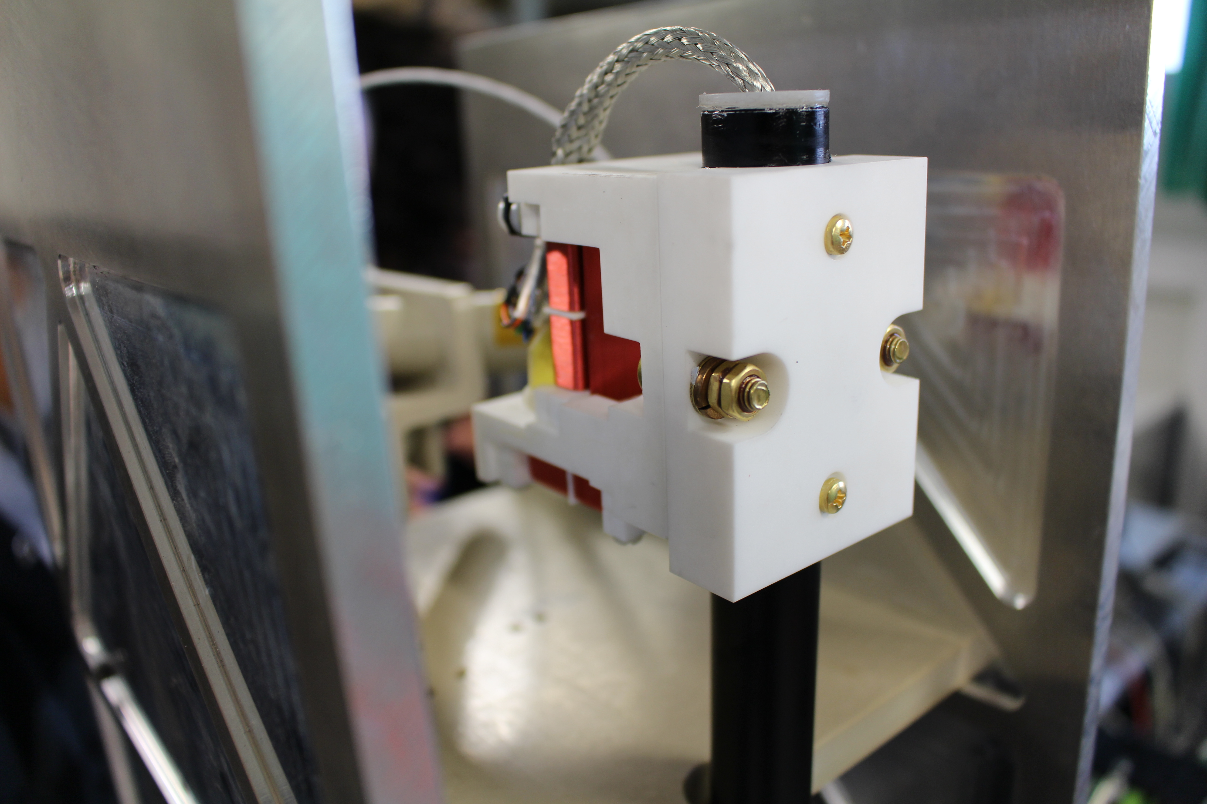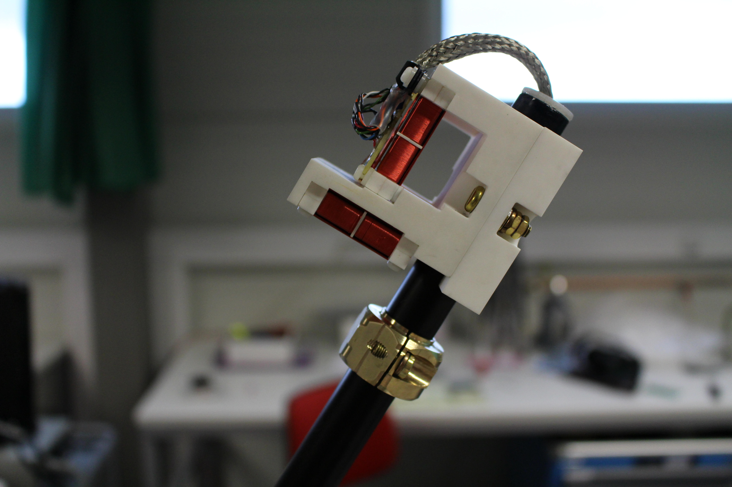

The sensor cable is affixed to the folding boom supports in several places with plastic zipstraps to prevent folding or kinking. This was deployed ~5 times with no issue. The sensor cable is then tied to the payload section superstructure with stuck-on pads and routed to the electronics box

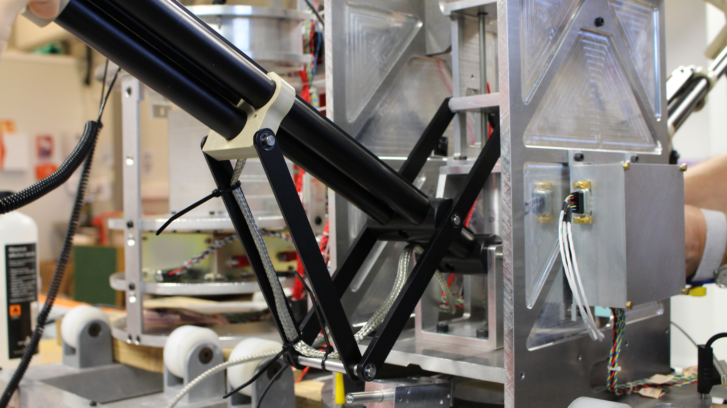

The sensor was aligned by eye (no better method available). On 2015-02-02 reference photos were taken during final integration which can be used to estimate the angles to the spacecraft axis. The boom was fully deployed by hand till hard contact. Sketches on the right were made by using Photoshop to draw lines along reference axes and recording the angle given.

|  |  |
| --- | --- |
|  |  |
|  |  |
|  |  |

# Final Integration of Electronics

The electronics were significantly modified between second integration, when the sensor was affixed to the rocket, and final integration when the electronics were permanently integrated. There was therefore no opportunity to calibrate the modified electronics with the flight sensor. Calibration and development work was completed using the plastic flight space sensor.

The plastic prototype sensor and the macor flight sensor are known to have different timings. The ADCOFFSET value for the flight sensor was determined back when the electronics used the unfiltered outputs rather than the filtered outputs. To check the timing the new electronics were connected to the flight sensor and a scope was attached to show the ADCtrigger line and each filtered output:

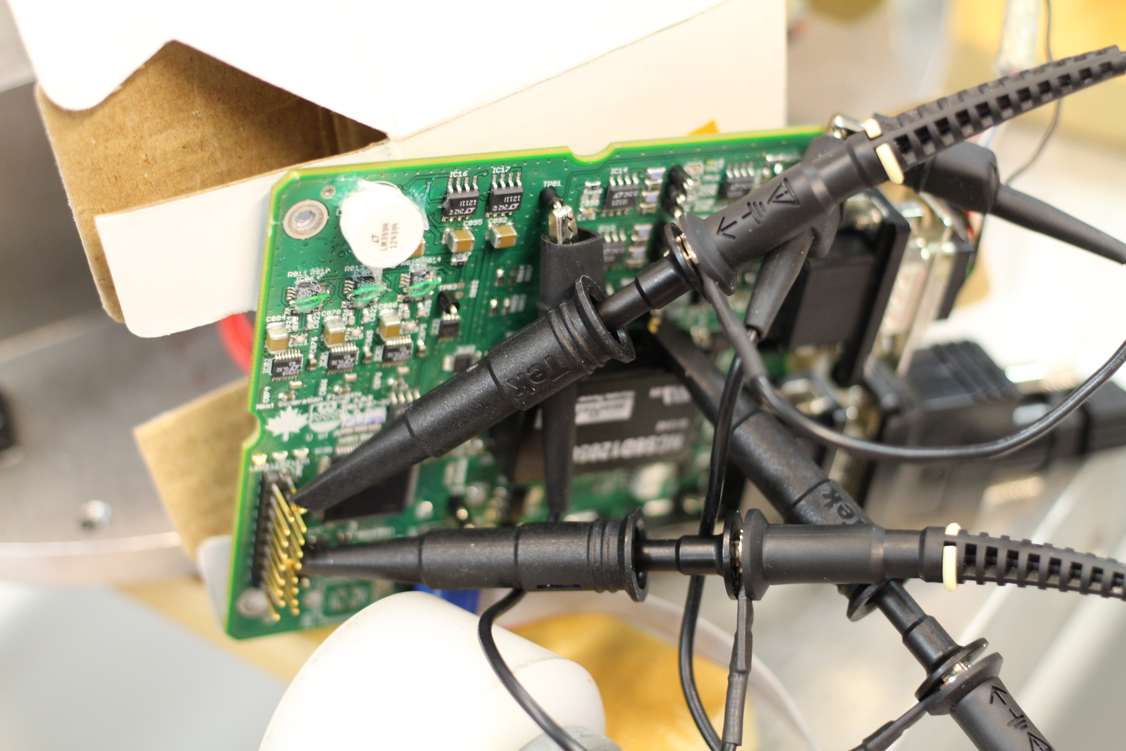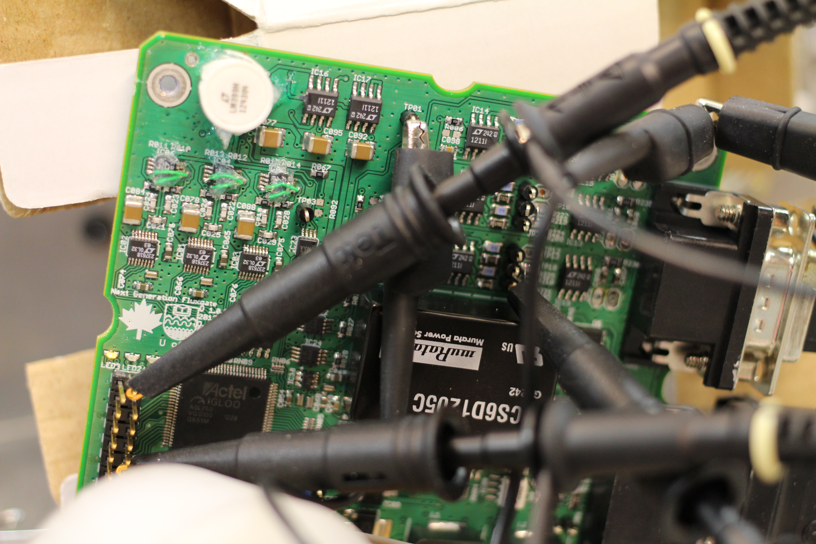

Flight board reprogrammed with adcoffset = 5 Scope captures show ADC trigger versus filtered analog signal.

X Channel ADC Trigger vs filtered analog signal

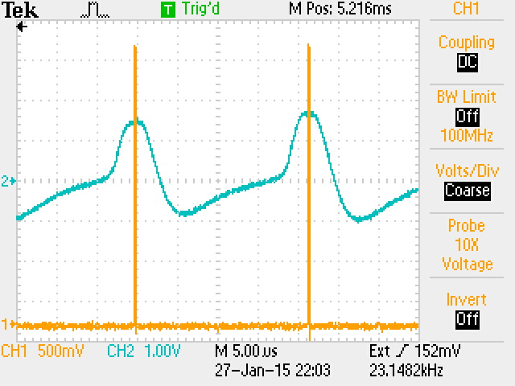

Y Channel ADC Trigger vs filtered analog signal

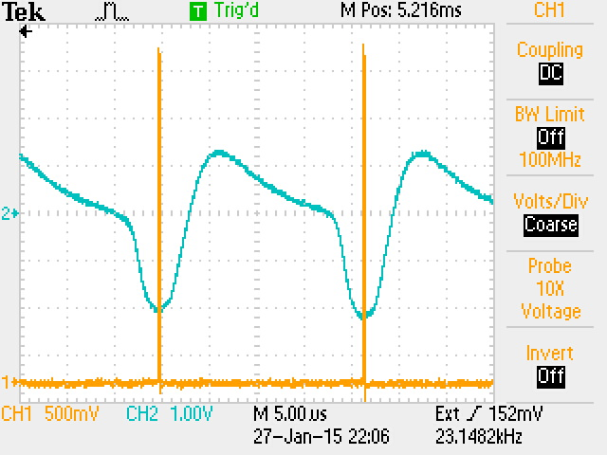

Z Channel ADC Trigger vs filtered analog signal

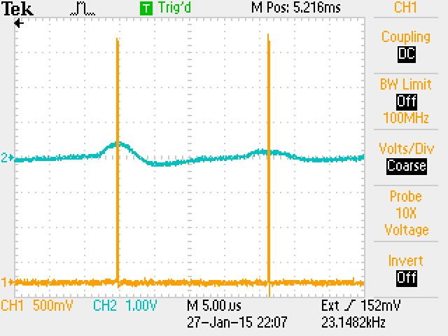

## Quiet Data

The three layer shield and a solenoid was shipped to the range for a final low-fidelity calibration however, as of 2015-02-02 the package had been in transit for more than a week and was not yet out for delivery. The French team had a travel shield which they estimated brought down the field by ~30 dB. The box lit could not be closed so we should expect poorer performance. The shield was placed around the sensor as below with paper towel used to ensure nothing was shorted out.

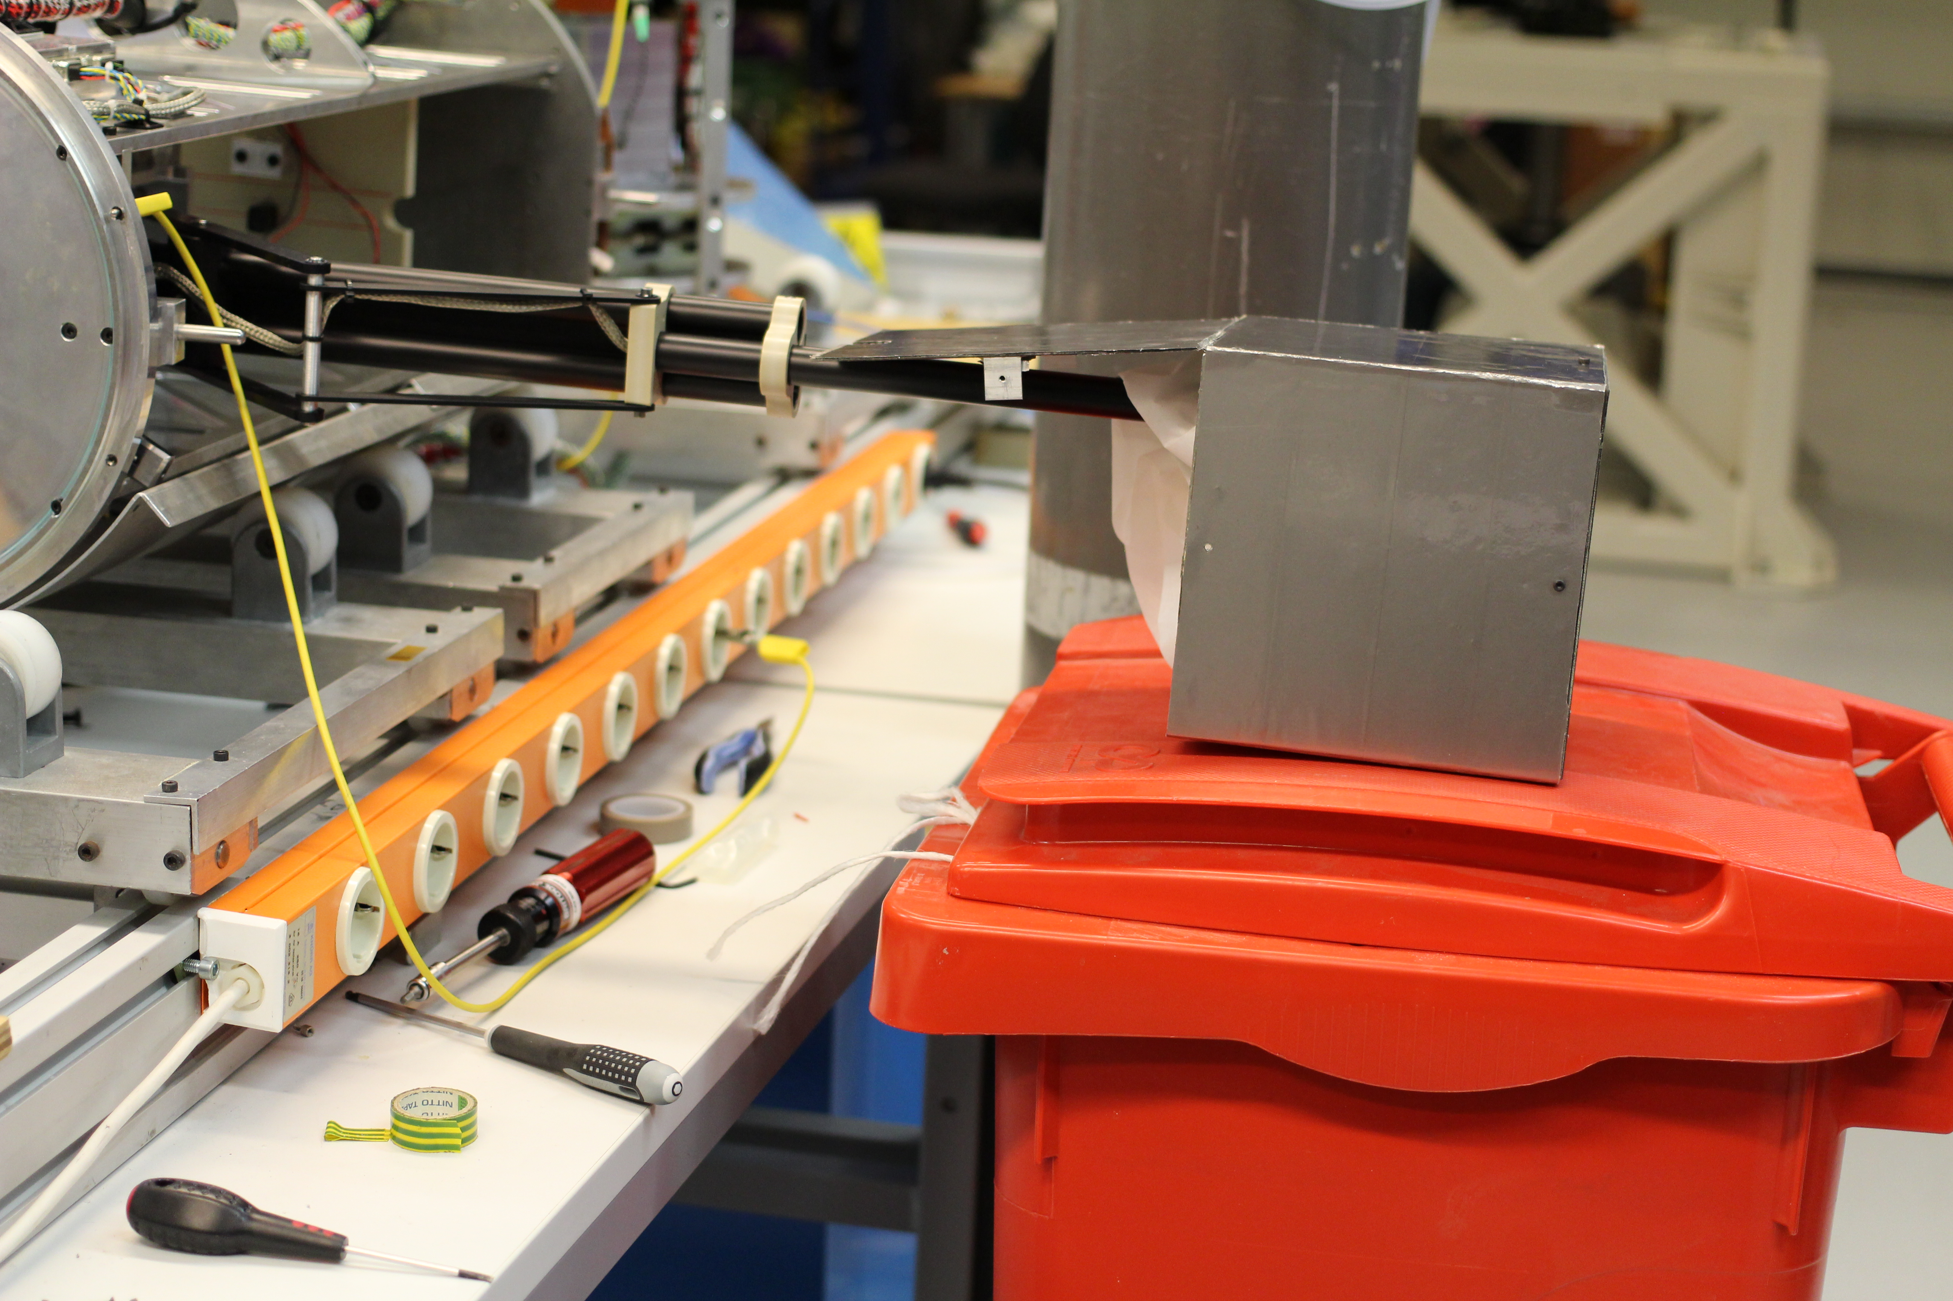

# Electronics box Integration

The electronics box had been kept at the range while the flight electronics were re-worked. The box was blown out to remove dust and minor debry. Two extra large ceramic caps which had been temporarily inserted across +5V0 and -5V0 at the FET bridge were desoldered and the area was wiped down with a wet towel.

The flight card was installed with all 4 bolts all of which had locktight blue. The lid was installed with all 8 bolts all of which had locktight blue.

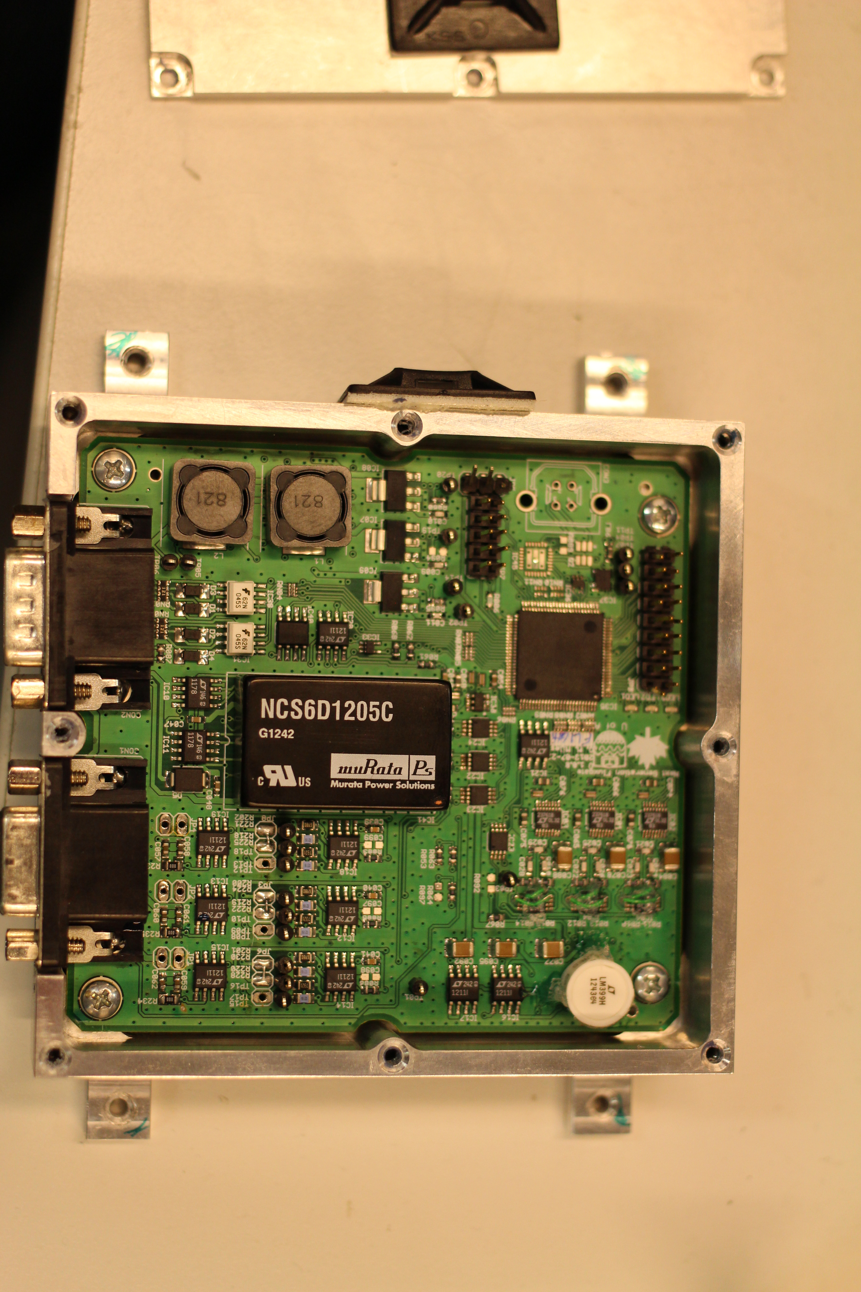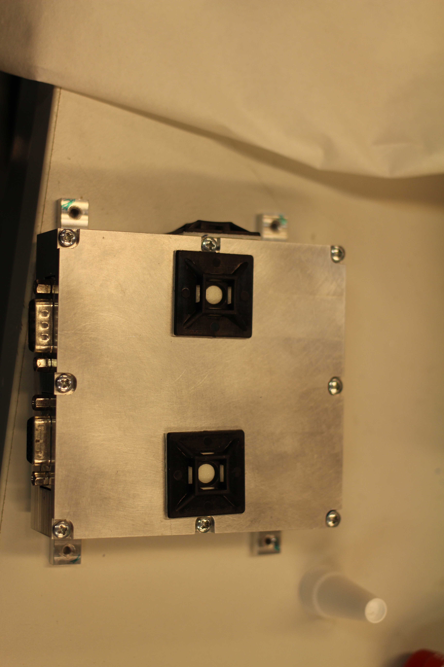

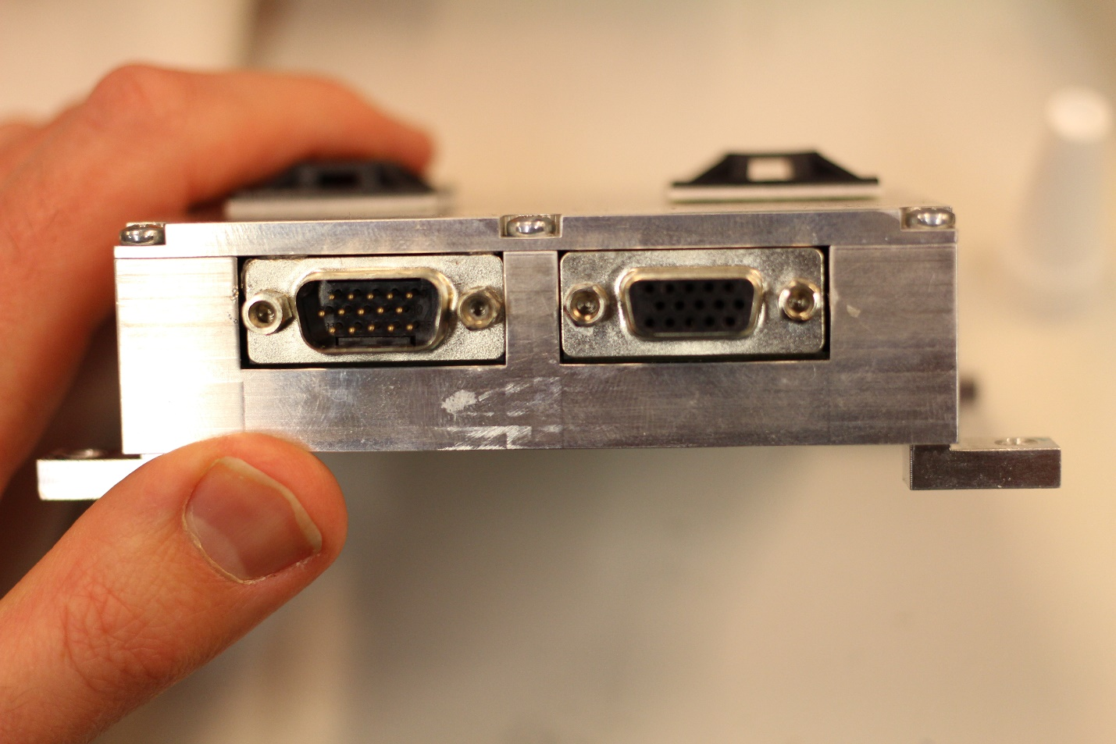

The box was attached to the hotel payload section by range personelle with four provided bolts.

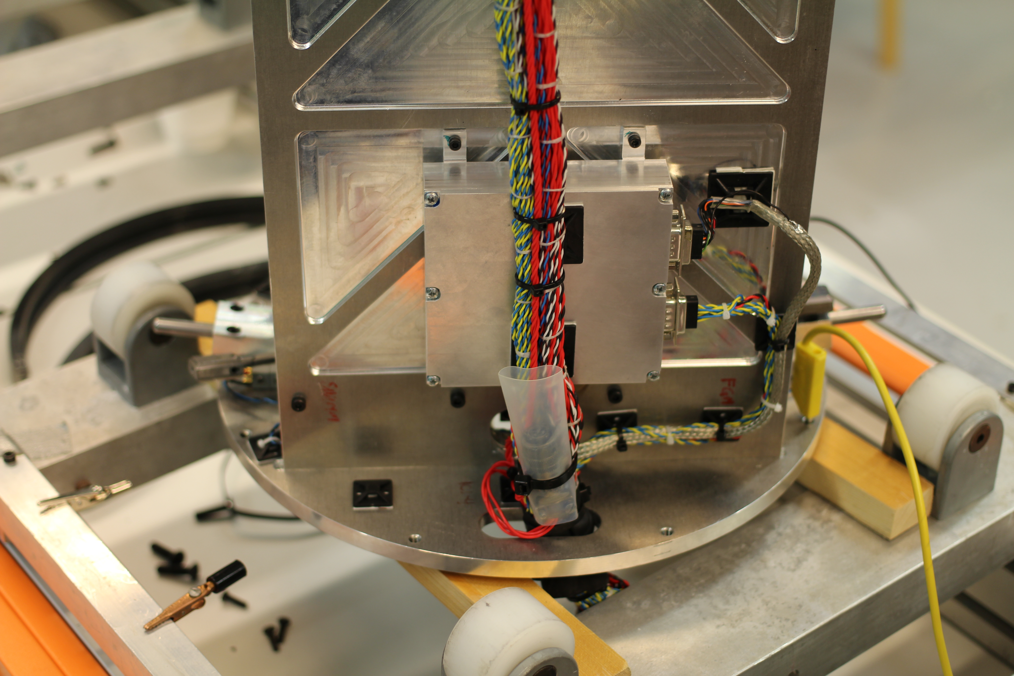

On 2015-02-02 range personelle secured the cables an noted that the sensor (right) connector wiggled more easily than the left (bus) connector. Range personel proposed to add RTV to add mechanical stability (not shown below).

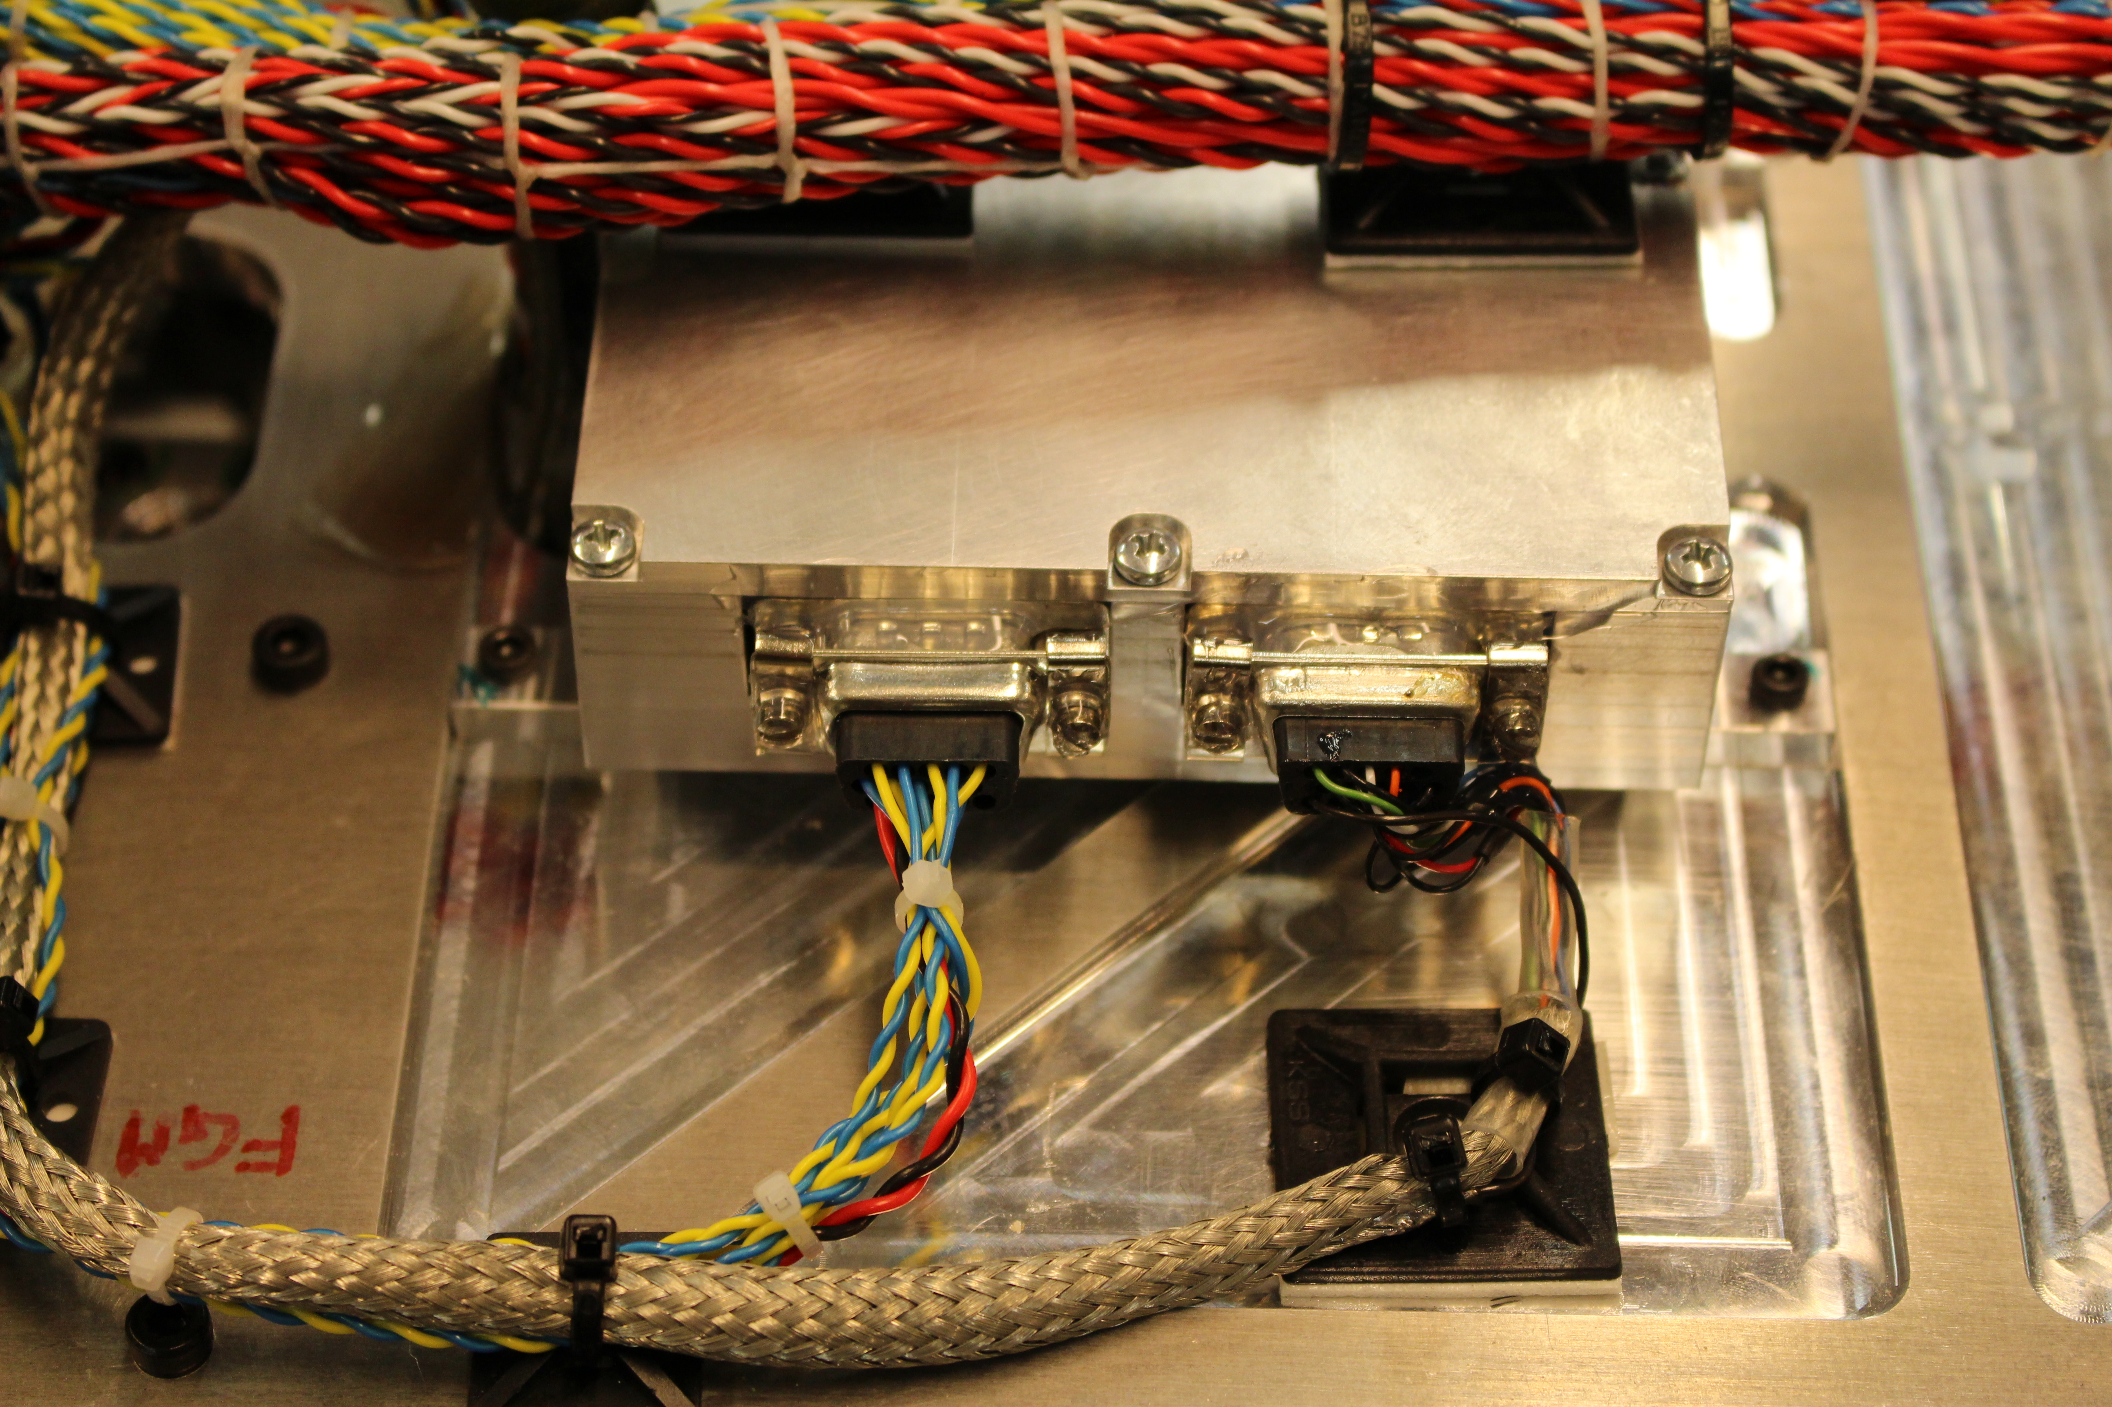

# Ambient field in integration hanger from LPP team

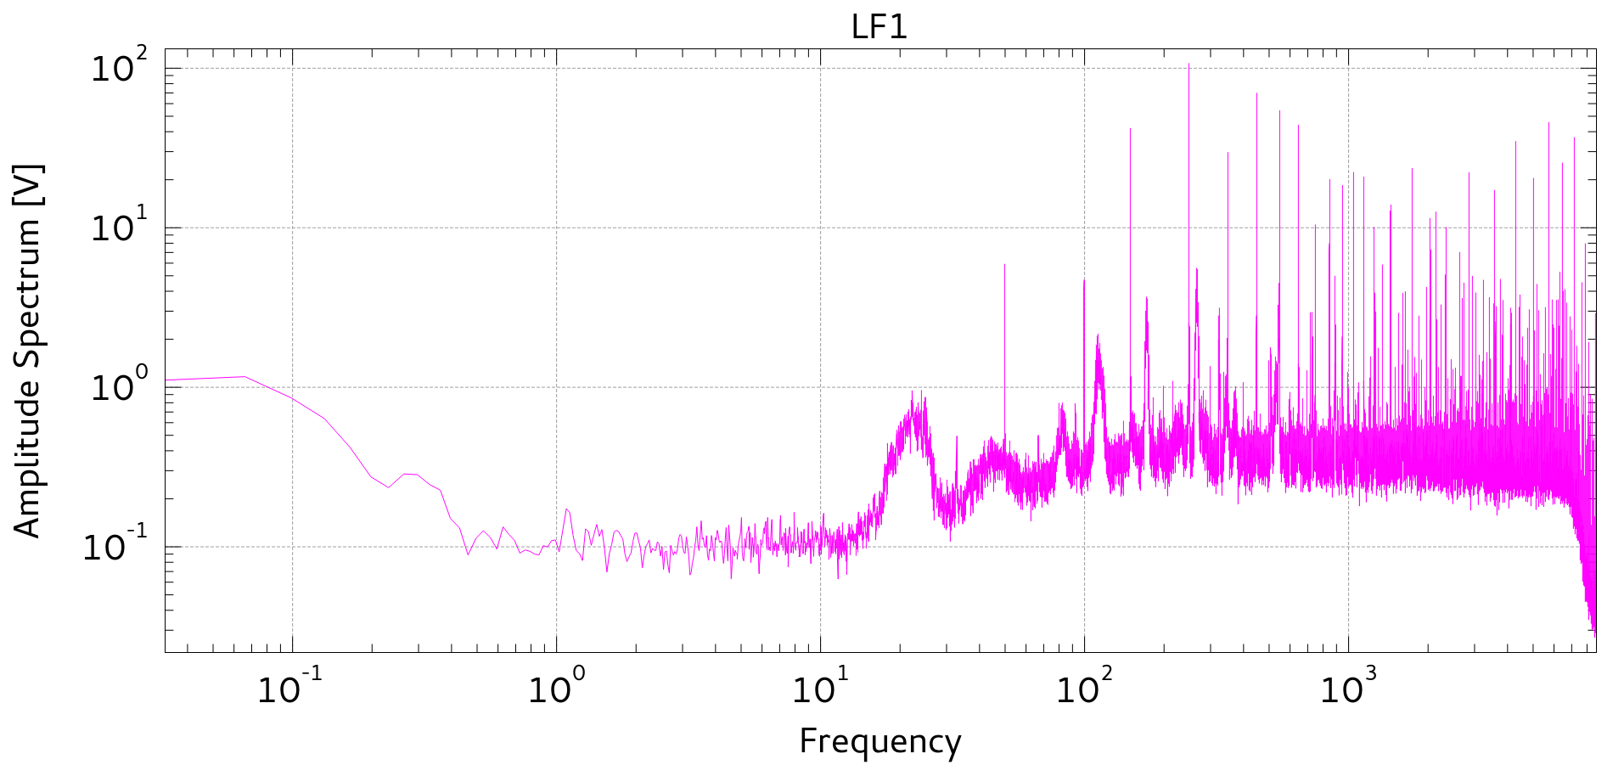

# Instrumental Zeroes

There was no opportunity to estimate the instrumental zeroes. The three layer shield had not arrived by the time the sensor cable was permanently affixed to the electronics box.

# EIDEL Transfer Function

Attempts to plot the complete (32 bit) fluxgate output have been unsuccessful. Two’s complement numbers aren’t really supported and must be hacked to work using calibration points and interpolation. For visualisation purposes the top 16 bit word is sufficient. This leads to a transfer function of:

|  |  |  |  |
| --- | --- | --- | --- |
|  |  | Binary Value | Equiv. Magnetic Field |
| Midscale | 0 | 0 | 0 |
| Full Scale | (2^15)-1 | 32767 | -141815.4921 |
| - Full Scale | (2^15) | 32768 | 141815.4921 |
| Midscale - 1 LSB | (2^16) | 65536 | 0 |

I haven’t had a chance to test this well but it gives reasonable values and wiggles cleanly when I wave a screwdriver at the sensor.